Mahmuda Yasmin June, 2018

An Overview of the National Health Expenditure Trends, 1975 to 2017 in Private Health Sector.

A Brief Analysis on the Data of Private-sector health expenditure, categorized by province/territory, based upon data provided by CIHI.

An Overview of the National Health Expenditure Trends, 1975 to 2017 in Private Health Sector.

# *The Dataset in consideration is provided by CIHI (Canadian Institute for Health Information) for research and analysis purpose. It is analyzed and findings are presented as a project-work by MAHMUDA YASMIN. This dataset and other available datasets at CIHI are used for data analysis purpose and the findings of are presented in this report.*

# Overview:

The Dataset in consideration contains the details on Private sector health expenditure from 1975 to 2017 by province of Canada and the breakdown of the sectors that use the funds. The objective of this analysis is to learn about the trends, factors that may influence the expenditure and produce future forecast. *The analysis emphasizes on the validation of some hypotheses and modelling of the data from Statistical perspectives*.

# Introduction:

National Health Expenditure in Canada an important factor for the Canadian healthcare system. The breakdown analysis of the factors that use the funds helps us to give a broader view of the facts that are related to the healthcare expenditure. Provided from the CIHI website, the national healthcare expenditure is contributed from both Provincial (70% of the total) and Private (30% of the total). In this analysis, we are focusing on the Private Healthcare expenditure.

Our goal is to get an idea about the factors that may relate to the Private Healthcare Expenditure based upon exploratory and statistical analysis.

# Analysis:

Idea on the Data:

The Data set has several Factors in consideration -

* Data is focused on **Private Healthcare Expenditure**.
* Data is categorized by **13 different Province/ Territories** in Canada.
* **9 different factors that use the funds** are taken into consideration (Hospitals, Other Institutions, Physicians, Other Professionals, Drugs, Capital, Public Health, Administration, Other Health Spending).
* In general , Our event of interest i.e. the Healthcare Expenditure in Private sector, by Province is evaluated from 3 different perspectives-
  + (Total) Expenditures, per year and Annual percentage change by Year.
  + Percentage distribution among the Fund-using Factors and Annual percentage change by Year.
  + Per capita health expenditure and Annual percentage change by Year.

So the overall structure of the provided Dataset is -

OUR EVENT OF INTEREST

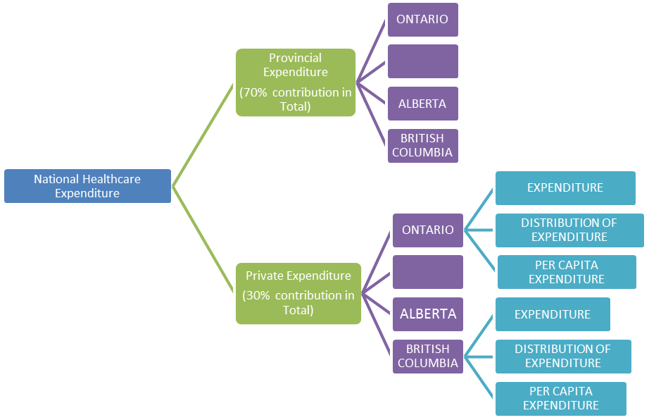

Goals:

* What are the factors that influence the Private Health Expenditure?
* Are they different from the factors that contribute into Total or Provincial Expenditure? (Since, the Private Health Care Expenditure is only 30% of the Total; there is a chance that the findings may be different from the Provincial Expenditure Analysis).
* Can Territory/ Province be a factor that influences the expenditure?
* Can other factors be associated with the Private Health Expenditure; such as Age, Gender, and GDP Growth etc.?
* Are the factors that use the funds (Physicians, Drugs etc.) are inter-related?
* What is the possible future Cost per Capita?

Observations and Considerations:

* Cells that had no values/ missing values were omitted during analysis.
* Our event of interest is the ‘Per Capita Expenditure’ factor as the response variable.
* Total expenditure could not be considered anywhere due to lack of information on the people who opted for the services.
* The expenditure may or may not differ significantly by Province. If it does, then we have to conduct different analysis for different Provinces.
* The Private Healthcare Expenditure may or may not be associated with the size of Population of the Province (e.g. larger provinces may have larger expenses).

[The larger Provinces are expected to have larger population which leads to larger expenditure. The Private Health Care facilities have different attributes than the Provincial and might not relate with the population size or with the economic status of the province.

No information was found on the number of people who get health benefits from the Private health expenditure; neither from the GSC-HR provided data, or from any other sources available on the CIHI website. So, the association between size of the population and Private health expenditure could not be detectable. NOTE: (Provincial/territorial government health expenditures by age and sex and use of funds (by province/territory) and further findings are available at CIHI website.]

* An interesting fact to check is that, whether the Fund-Using Factors (Hospitals, Other Institutions, Physicians, Other Professionals, Drugs, Capital, Public Health, Administration, Other Health Spending) are inter-related or not. Even though these factors are time dependent and may exhibit spurious correlation, there are chances that these factors may be correlated without time consideration. For example, if someone chooses Chiropractic therapy over medicinal drug, then there might be negative correlation observed between these two factors. This may or may not be grown over time, so details data can help to determine whether this kind of associations really exists or not.

Analysis:

* **Can Territory/ Province be a factor that influences the expenditure?**

We conducted an exploratory and a statistical analysis of hypothesis testing to make our decision, and it shows that the Private sector heath expenditure differs significantly by province. So, for further analysis, we have to consider different analysis and results for different provinces.

Details of Analysis- *Analysis 1, Plot 1.1, Plot 1.2* page 8-10

* **Do all the fund-utilizing sectors (Physicians, Drugs etc.) use equal amount of money?**

From the details graph of the historic data (Analysis 2, Plot 2.1, Page, 11), the findings are-

1. The private health coverage is important to buy **Drugs** in almost all of the provinces.
2. Also ‘**Other Professionals**’ (represent expenditures for dentists, denturists, chiropractors, optometrists, massage therapists, osteopaths, physiotherapists, podiatrists, psychologists, nurses and naturopaths) consume a major portion of the private healthcare funds.
3. The expenditure for **Hospital** is highest in **Northwest Territories**.
4. The expenditure for **Other Institutions** (residential care types of facilities such as nursing homes) is highest in **Yukon**.
5. **Physicians** consume the least amount of Private health funds in all provinces.

*To conduct a statistical analysis, a mixed-effect GLM with time variable as regressor may help us find out the effect of the significant factors, correlation and effect of time in this data.*

• **What is the possible future Cost per Capita?**

We have to calculate future Cost per Capita for every province individually. We consider the data for Ontario province. From the trend of *Plot 3.1, page -12,* it is visible that all the Fund-Using factors have an uprising attribute.

To get the precise forecasted value, we modelled on the data from 1975 to 2016, omitting the 2016 and 2017 forecasted value to compare with our forecasted value.

The best model is selected by root mean square error of prediction (RMSE) criteria and the models in considerations are ETS, Holt-Winters, ARIMA modelling and LOESS smoothing technique is used.

Forecast from our Analysis-

|  |  |  |  |  |  |  |  |  |  |  |
| --- | --- | --- | --- | --- | --- | --- | --- | --- | --- | --- |
| **Year** | **forecast Hospitals** | **forecast Other Institutions** | **forecast Physicians** | **forecast Other Professionals** | **forecast Drugs** | **forecast Capital** | **forecast Public Health** | **forecast Administration** | **forecast Other Health Spending** | **forecast Total** |
| 2016 | 266.48 | 207.657 | 8.42209 | 614.886 | 697.326 | 67.225 | 0 | 83.1766 | 111.927 | 2057.1 |
| 2017 | 273.314 | 211.004 | 8.64817 | 629.53 | 712.153 | 68.9188 | 0 | 84.3656 | 114.944 | 2102.88 |
| 2018 | 280.148 | 214.351 | 8.87425 | 644.173 | 726.981 | 70.6127 | 0 | 85.5546 | 117.962 | 2148.66 |
| 2019 | 286.981 | 217.697 | 9.10032 | 658.817 | 741.808 | 72.3065 | 0 | 86.7436 | 120.98 | 2194.43 |
| 2020 | 293.815 | 221.044 | 9.3264 | 673.46 | 756.636 | 74.0003 | 0 | 87.9327 | 123.997 | 2240.21 |
| 2021 | 300.649 | 224.391 | 9.55248 | 688.104 | 771.463 | 75.6941 | 0 | 89.1217 | 127.015 | 2285.99 |
| 2022 | 307.482 | 227.738 | 9.77856 | 702.747 | 786.29 | 77.3879 | 0 | 90.3107 | 130.033 | 2331.77 |
| 2023 | 314.316 | 231.085 | 10.0046 | 717.391 | 801.118 | 79.0818 | 0 | 91.4998 | 133.051 | 2377.55 |
| 2024 | 321.15 | 234.432 | 10.2307 | 732.034 | 815.945 | 80.7756 | 0 | 92.6888 | 136.068 | 2423.32 |
| 2025 | 327.984 | 237.779 | 10.4568 | 746.678 | 830.772 | 82.4694 | 0 | 93.8778 | 139.086 | 2469.1 |

Forecast provided with the dataset-

|  |  |  |  |  |  |  |  |  |  |  |
| --- | --- | --- | --- | --- | --- | --- | --- | --- | --- | --- |
| **Year** | **forecast Hospitals** | **forecast Other Institutions** | **forecast Physicians** | **forecast Other Professionals** | **forecast Drugs** | **forecast Capital** | **forecast Public Health** | **forecast Administration** | **forecast Other Health Spending** | **forecast Total** |
| 2016 f | 269.575 | 212.385 | 8.34905 | 621.153 | 703.551 | 71.4205 | 0 | 85.0145 | 105.617 | 2077.07 |
| 2017 f | 278.263 | 221.821 | 8.95726 | 645.801 | 735.193 | 79.8538 | 0 | 89.0863 | 107.371 | 2166.35 |

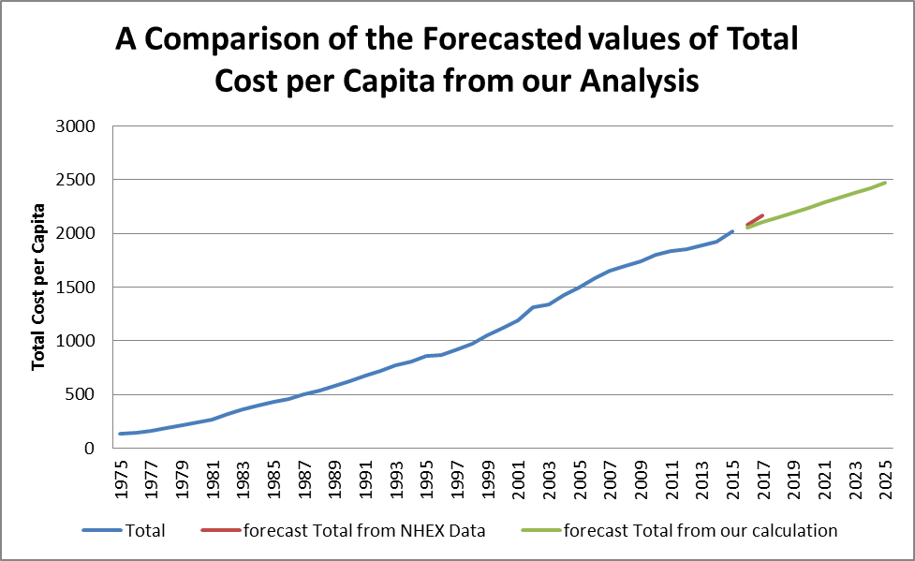

Facts for Future Analysis:

* Are the factors that use the funds (Physicians, Drugs etc.) are inter-related?
* Can other factors be associated with the Private Health Expenditure; such as Age, Gender, and GDP Growth etc.?

**Analysis 1: Examine whether the Expenditure differs by Province**

Plot 1.1 : Bar diagram of Average Cost per Capita in the time period of 1975-2015 by Province.

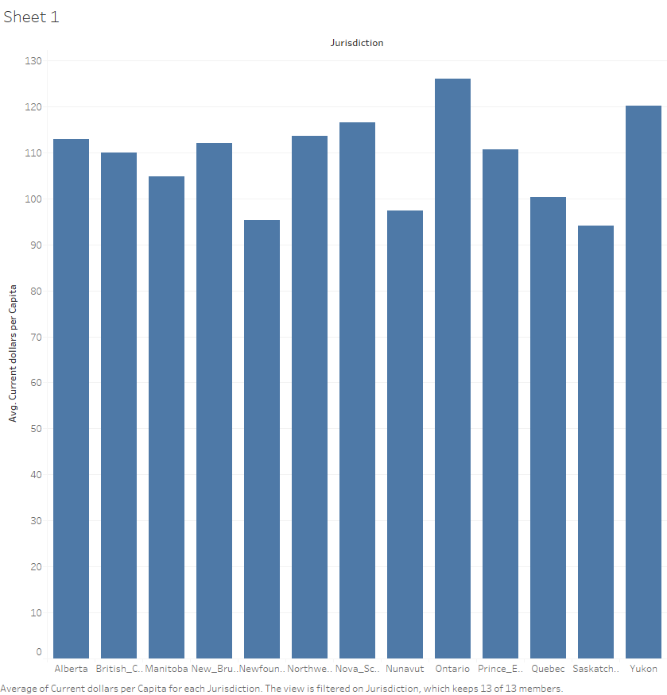

One-way ANOVA: Current_dollars_per_Capita versus Jurisdiction

Method

|  |  |
| --- | --- |
| Null hypothesis | All means are equal |
| Alternative hypothesis | Not all means are equal |
| Significance level | α = 0.05 |
| Rows unused | 259 |

*Equal variances were assumed for the analysis.*

Factor Information

|  |  |  |
| --- | --- | --- |
| Factor | Levels | Values |
| Jurisdiction | 13 | Alberta, British_Columbia, Manitoba, New_Brunswick, Newfoundland_and_Labrador, Northwest_Territories, Nova_Scotia, Nunavut, Ontario, Prince_Edward_Island, Quebec, Saskatchewan, Yukon |

Analysis of Variance

|  |  |  |  |  |  |
| --- | --- | --- | --- | --- | --- |
| Source | DF | Adj SS | Adj MS | F-Value | P-Value |
| Jurisdiction | 12 | 1098081 | 91507 | 0.88 | 0.568 |
| Error | 5318 | 553642326 | 104107 |  |  |
| Total | 5330 | 554740406 |  |  |  |

Model Summary

|  |  |  |  |
| --- | --- | --- | --- |
| S | R-sq | R-sq(adj) | R-sq(pred) |
| 322.657 | 0.20% | 0.00% | 0.00% |

Means

|  |  |  |  |  |
| --- | --- | --- | --- | --- |
| Jurisdiction | N | Mean | StDev | 95% CI |
| Alberta | 430 | 178.6 | 336.8 | (148.1, 209.1) |
| British_Columbia | 430 | 175.4 | 319.2 | (144.9, 205.9) |
| Manitoba | 430 | 167.8 | 306.6 | (137.3, 198.3) |
| New_Brunswick | 430 | 179.2 | 345.7 | (148.7, 209.7) |
| Newfoundland_and_Labrador | 430 | 150.7 | 287.1 | (120.2, 181.2) |
| Northwest_Territories | 430 | 158.0 | 313.6 | (127.5, 188.5) |
| Nova_Scotia | 430 | 182.7 | 353.0 | (152.2, 213.2) |
| Nunavut | 171 | 150.3 | 220.0 | (101.9, 198.7) |
| Ontario | 430 | 201.5 | 367.8 | (171.0, 232.0) |
| Prince_Edward_Island | 430 | 176.0 | 320.8 | (145.5, 206.5) |
| Quebec | 430 | 159.5 | 302.4 | (129.0, 190.0) |
| Saskatchewan | 430 | 150.5 | 281.7 | (120.0, 181.0) |
| Yukon | 430 | 167.2 | 357.9 | (136.7, 197.7) |

*Pooled StDev = 322.657*

Tukey Pairwise Comparisons

Grouping Information Using the Tukey Method and 95% Confidence

|  |  |  |  |
| --- | --- | --- | --- |
| Jurisdiction | N | Mean | Grouping |
| Ontario | 430 | 201.5 | A |
| Nova_Scotia | 430 | 182.7 | A |
| New_Brunswick | 430 | 179.2 | A |
| Alberta | 430 | 178.6 | A |
| Prince_Edward_Island | 430 | 176.0 | A |
| British_Columbia | 430 | 175.4 | A |
| Manitoba | 430 | 167.8 | A |
| Yukon | 430 | 167.2 | A |
| Quebec | 430 | 159.5 | A |
| Northwest_Territories | 430 | 158.0 | A |
| Newfoundland_and_Labrador | 430 | 150.7 | A |
| Saskatchewan | 430 | 150.5 | A |
| Nunavut | 171 | 150.3 | A |

*Means that do not share a letter are significantly different.*

Plot 1.2 : Interval diagram of Average Cost per Capita in the time period of 1975-2015 by Province.



**Analysis 2: • Do all the fund-utilizing sectors (Physicians, Drugs etc.) use equal amount of money?**

Plot 2.1: Bar diagram of Average Cost per Capita by use of funds, by Province.

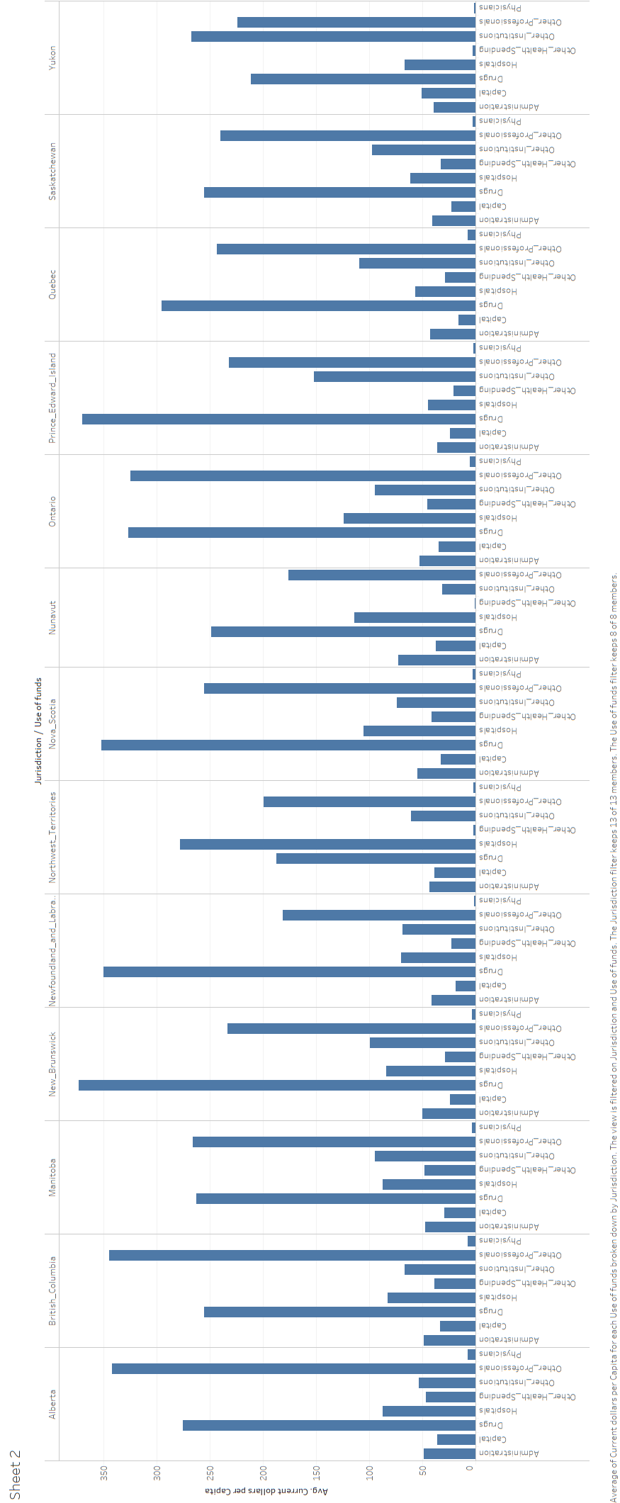

**Analysis 3: What is the possible future Cost per Capita?**

Plot 3.1: Trend of Average Cost per Capita per year for different factors that utilize the funds, for Ontario

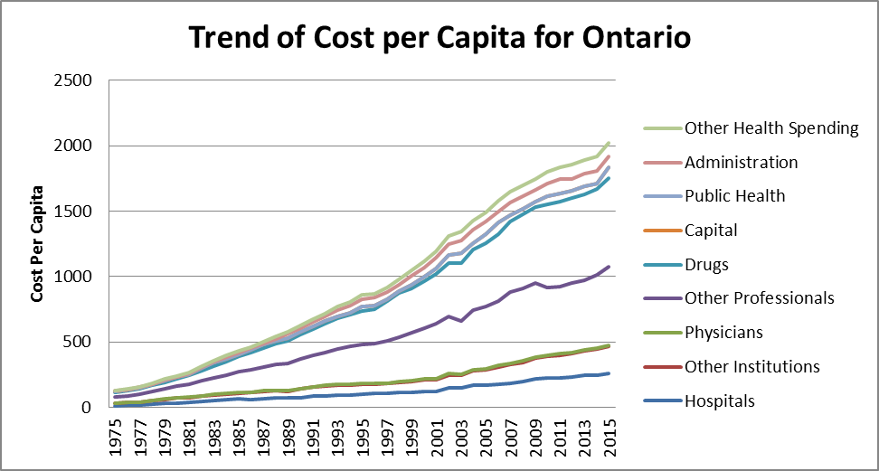

Conclusion:

The Summary of the Key findings from this analysis are-

* The Private Health Sector Expenditure in different province wise in Canada.
* The expenditure for Private Health is highest for drugs, and this is high in all of the provinces.
* Medical Professionals other than Physicians consume a major portion of the private healthcare funds in all provinces in Canada.
* The expenditure for Hospital is highest in Northwest Territories.
* The expenditure for Other Institutions (residential care types of facilities, such as nursing homes) is highest in Yukon.
* The Trend lines of all kind of expenses are uprising with time.
* Private-sector per capita health expenditure is expected to be 2057 $ in 2016, and 2103$ in 2017.

__________________________________________________